

National Textile University
Department of Computer Science
Subject
Mobile App Development
Submitted to:
Sir Rehan Sarwar

Submitted by:
Hadi Muhammad
Registration Number
23-NTU-CS-1160

Lab Task
03
Semester
6th

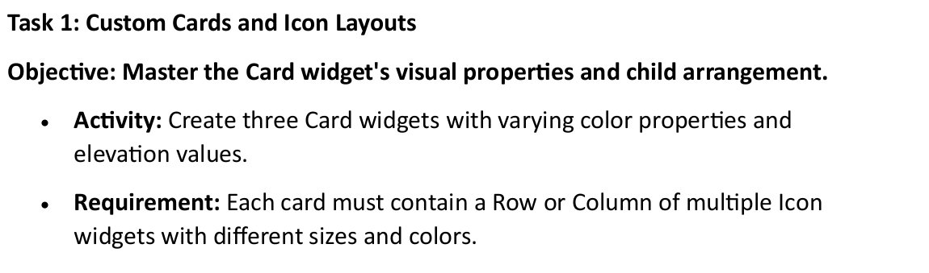

Code:
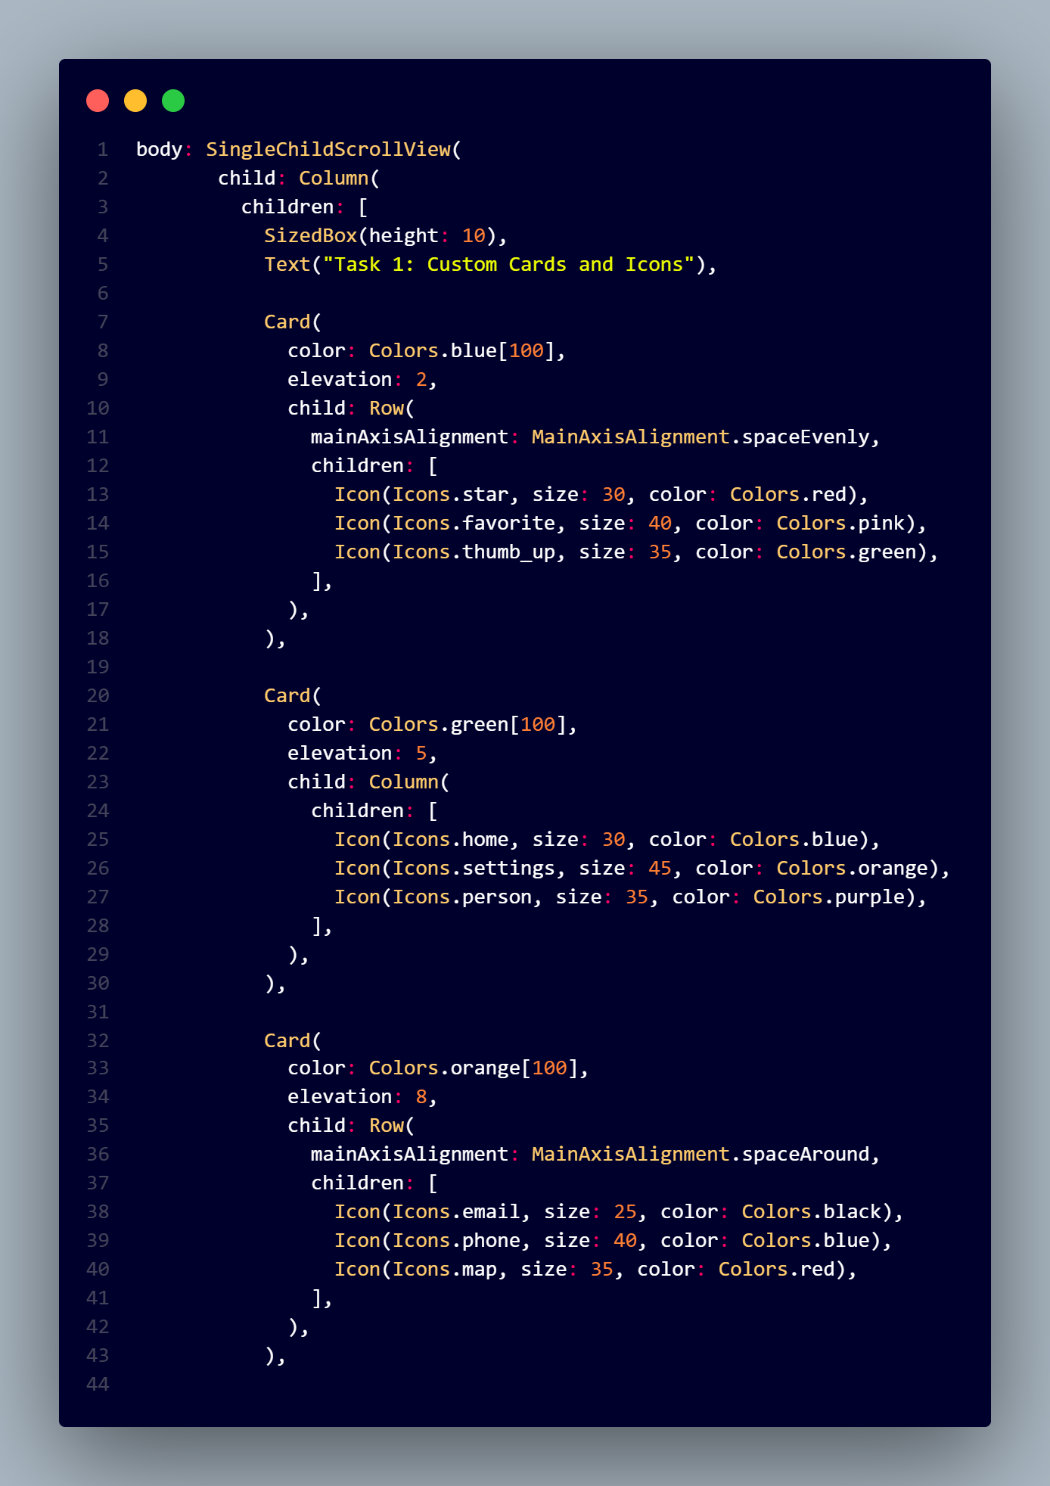
Output:
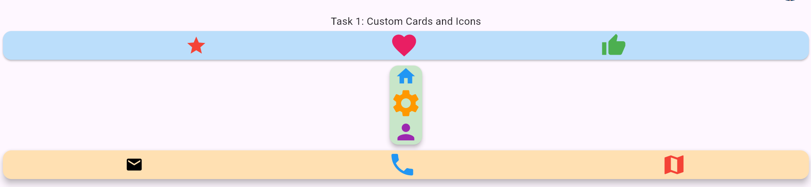

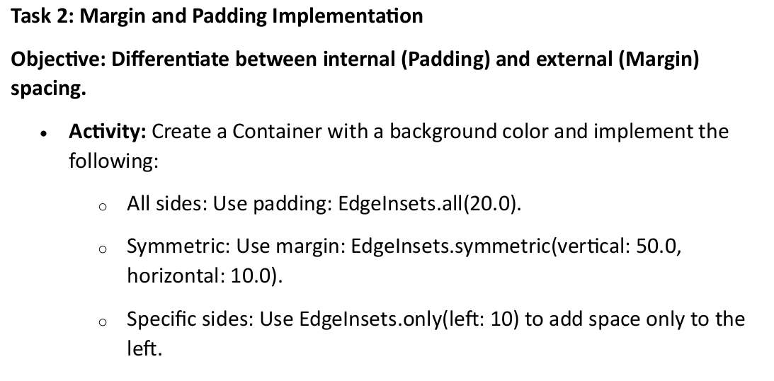
Code:
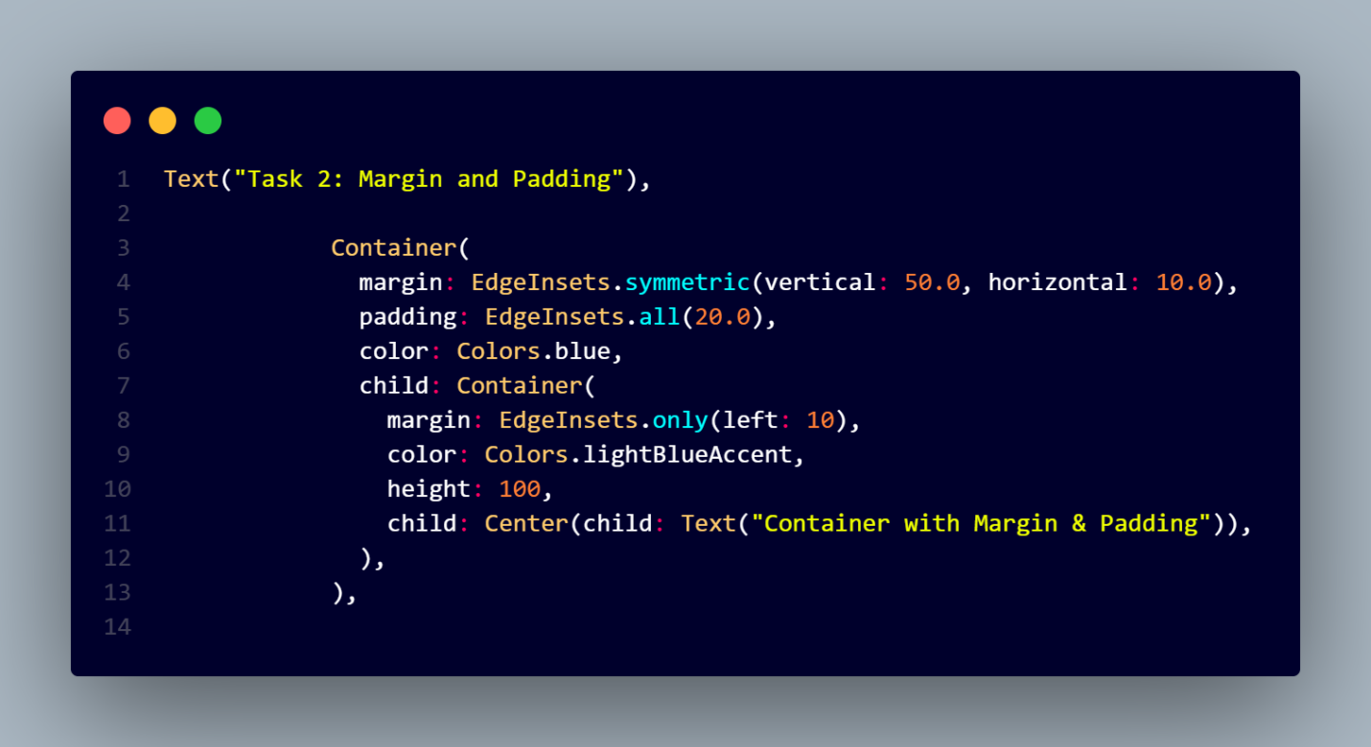
Output:

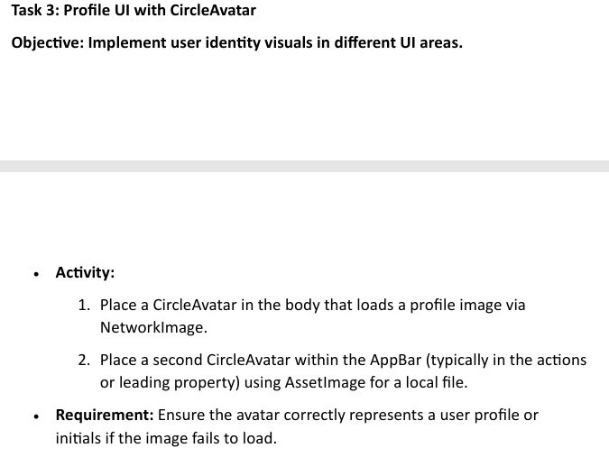
Code:
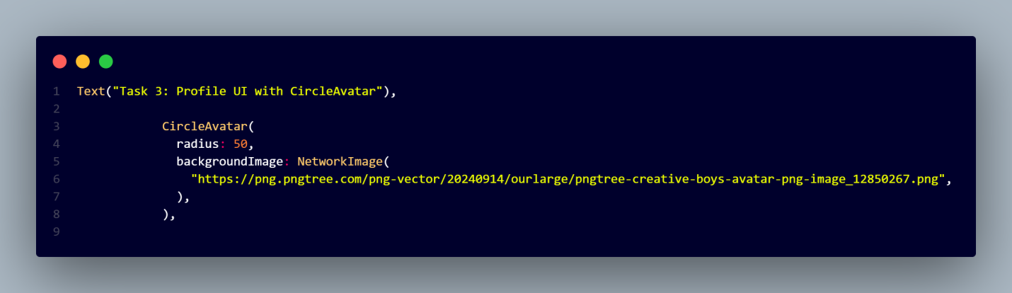
Output:

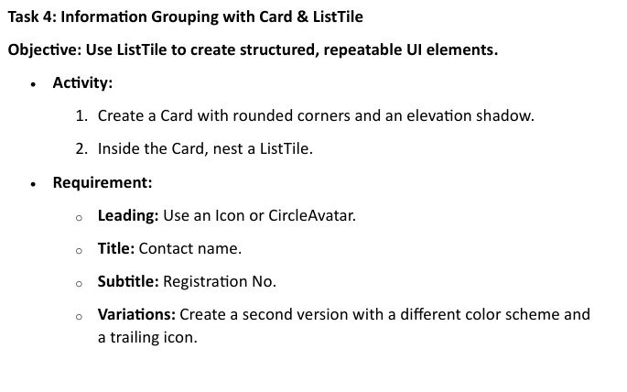
Code:
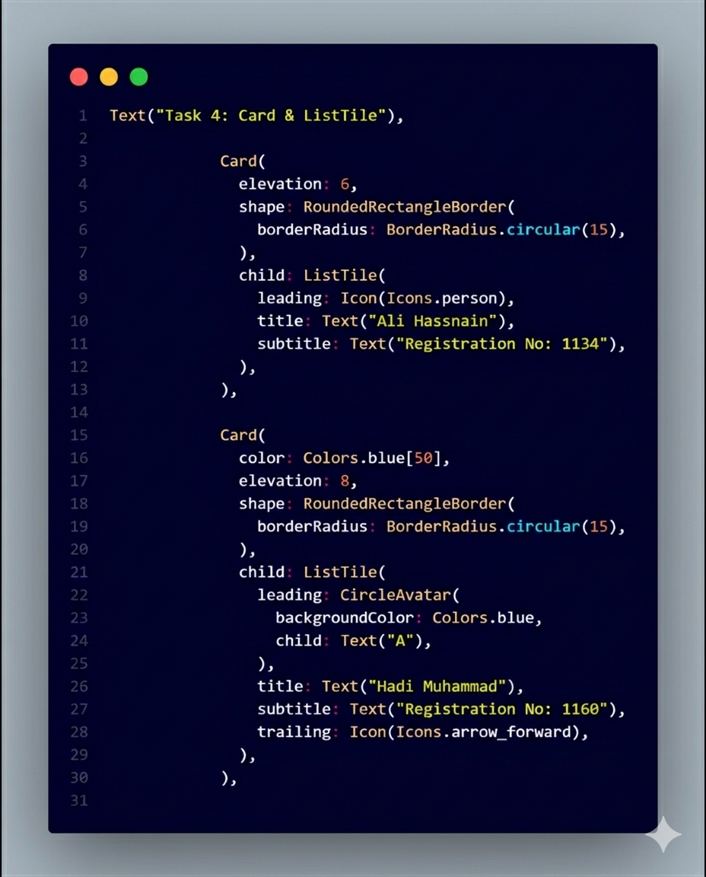
Output:
